-:: Project Definition ::-

A Project Report
Submitted to

Noble University, Junagadh


for the Partial requirement fulfillment in

Bachelor of Computer Application
Sem - 2

Prepared by
Karan Sanghavi (Enrolment No.: 240431210)

Guided by
Mr. Jasmin Soni

Noble BCA College,
Faculty of Computer Application, Noble University - Junagadh

Certificate

This is to certify that the Project report entitled Vimal Agency is a bonafide record of project work done by Karan Sanghavi Enrollment No.: 240431210 under my supervision and submitted to Noble University in partial fulfillment for Bachelor of Computer Application Semester – 2.

Signature of the Guide :
Name of Project Guide : Mr. Jasmin Soni
Designation : Faculty of Bachelor of Computer Application

Acknowledgment

As students, it was really a big task for us to prepare the project. I am very grateful to all who helped me in preparing this project. I was fortunate to get guidance and kind help from our professor Mr. Jasmine Soni.

I would like to especially thank our Dean and Project Guide for providing such a great platform for this project. We are very happy to provide an opportunity for a project in HTML, CSS. I am grateful for these suggestions. I am sincerely grateful to them.

Student Name : Karan Sanghavi
Enrollment No. : 240431210
Program : BCA

Table of Content

Sr. No. | Description | Page No.
1 | Introduction | 1
1.1 | Student Profile | 1
1.2 | Project Profile | 2
2 | System Snapshot | 3
3 | Limitation of Project
4 | Future scope of the project
5 | Bibliography

INTRODUCTION

- Introduction:
The Vimal Agency Website is an online platform designed to showcase and sell a Balaji Wafers providing users with a seamless and convenient shopping experience. It features an intuitive user interface, product listings with detailed specifications, and customer reviews. The website ensures easy navigation, allowing customers to browse, compare, and purchase water purification systems effortlessly from their homes. It is developed using HTML & CSS. This project aims to create a reliable e-commerce platform that not only simplifies the shopping process but also enhances customer engagement through feedback and support features.

  - Student Profile:

Student Name : Karan Sanghavi
Enrolment No. : 240431210

  - Project Profile :

Project on : E – Commerce Website
Developed by : Karan Sanghavi | Enrolment No. 240431210
Sem -Year : B.C.A Sem 2nd 2024-2025.
Guidance By : Jasmin Soni
Technology : HTML, C.S.S. & JavaScript
Platform : Windows
Submitted To : Faculty of Bachelor of Computer Application, Noble University.

SYSTEM SNAPSHOTS
- System Snapshot

Home Page
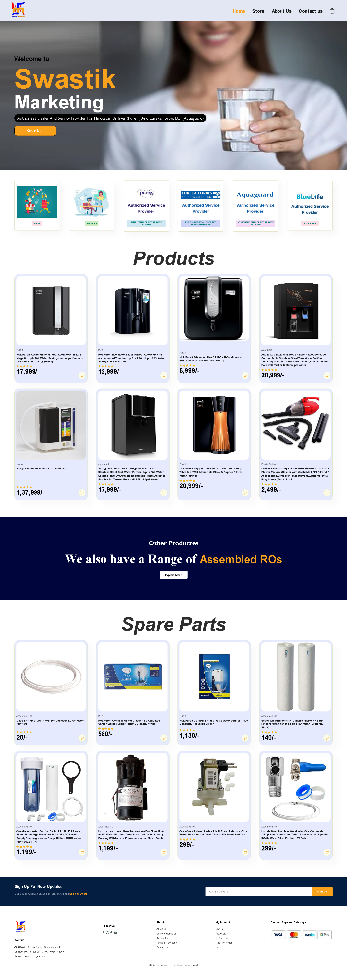

Description :
Store Page
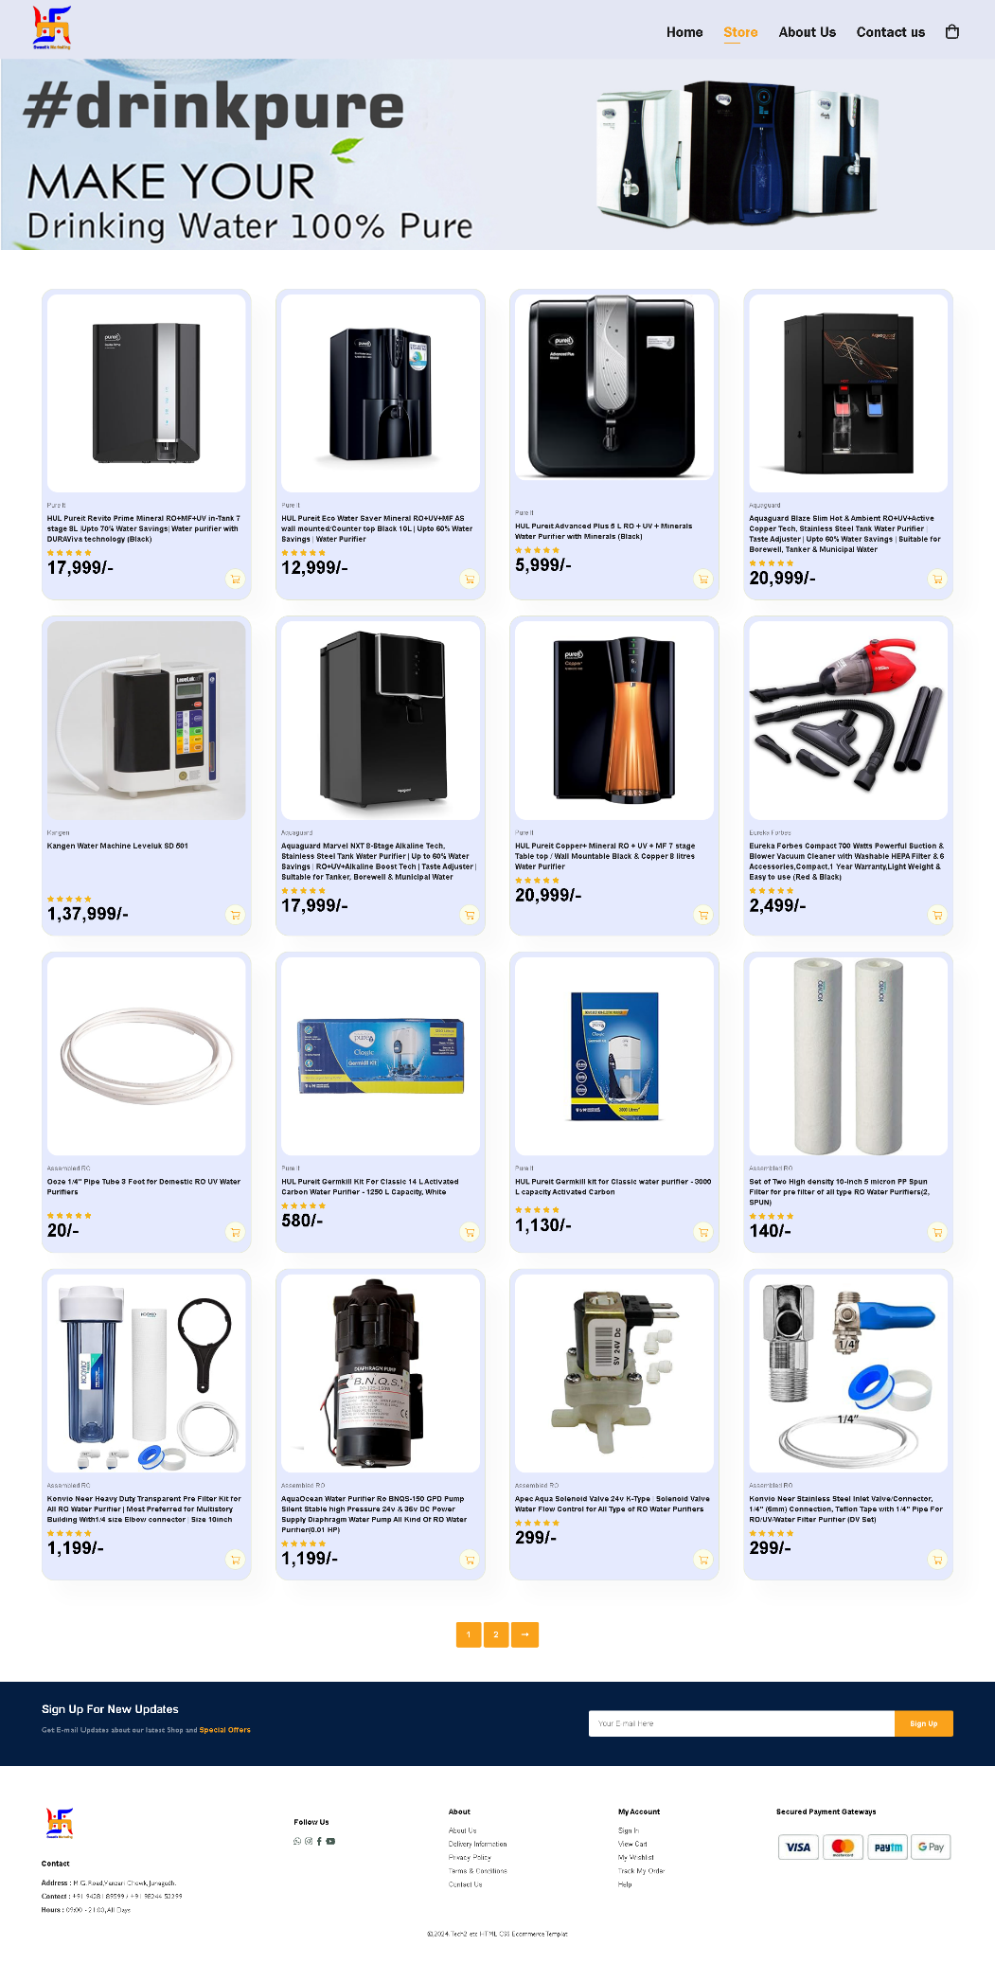
Description:

Store Page – 2

Description:

About Us Page
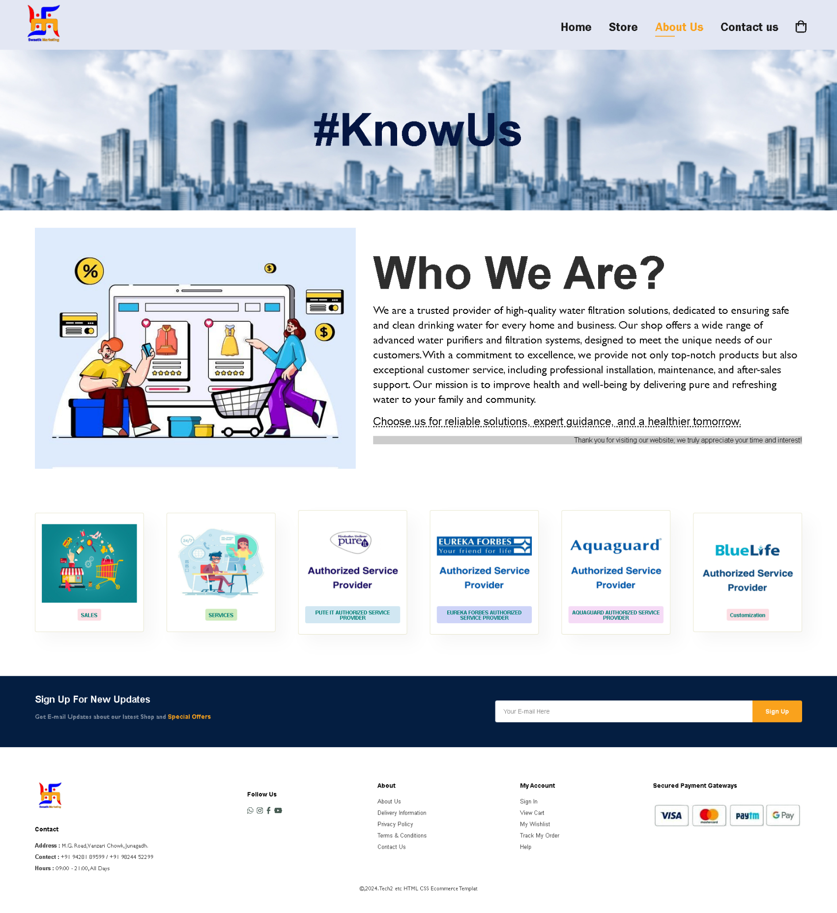

Description:

Contact us Page

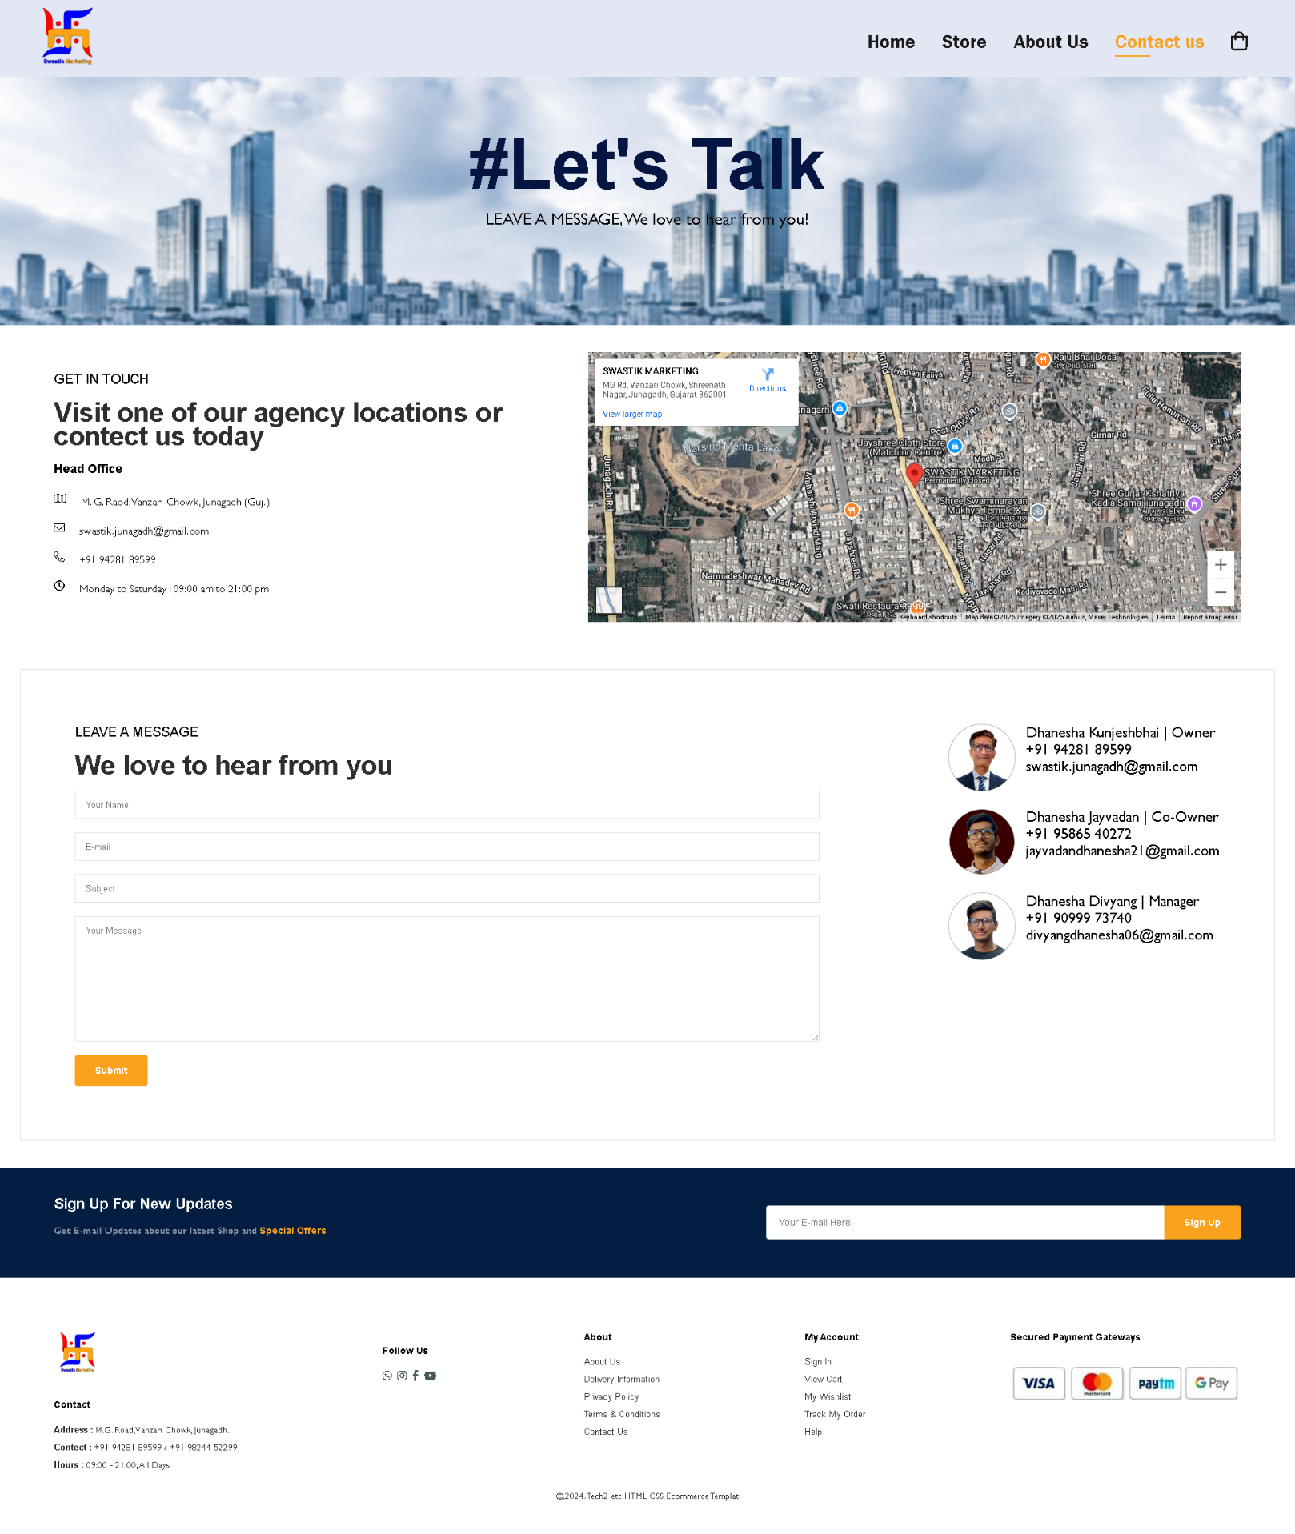

Description:

Cart Page

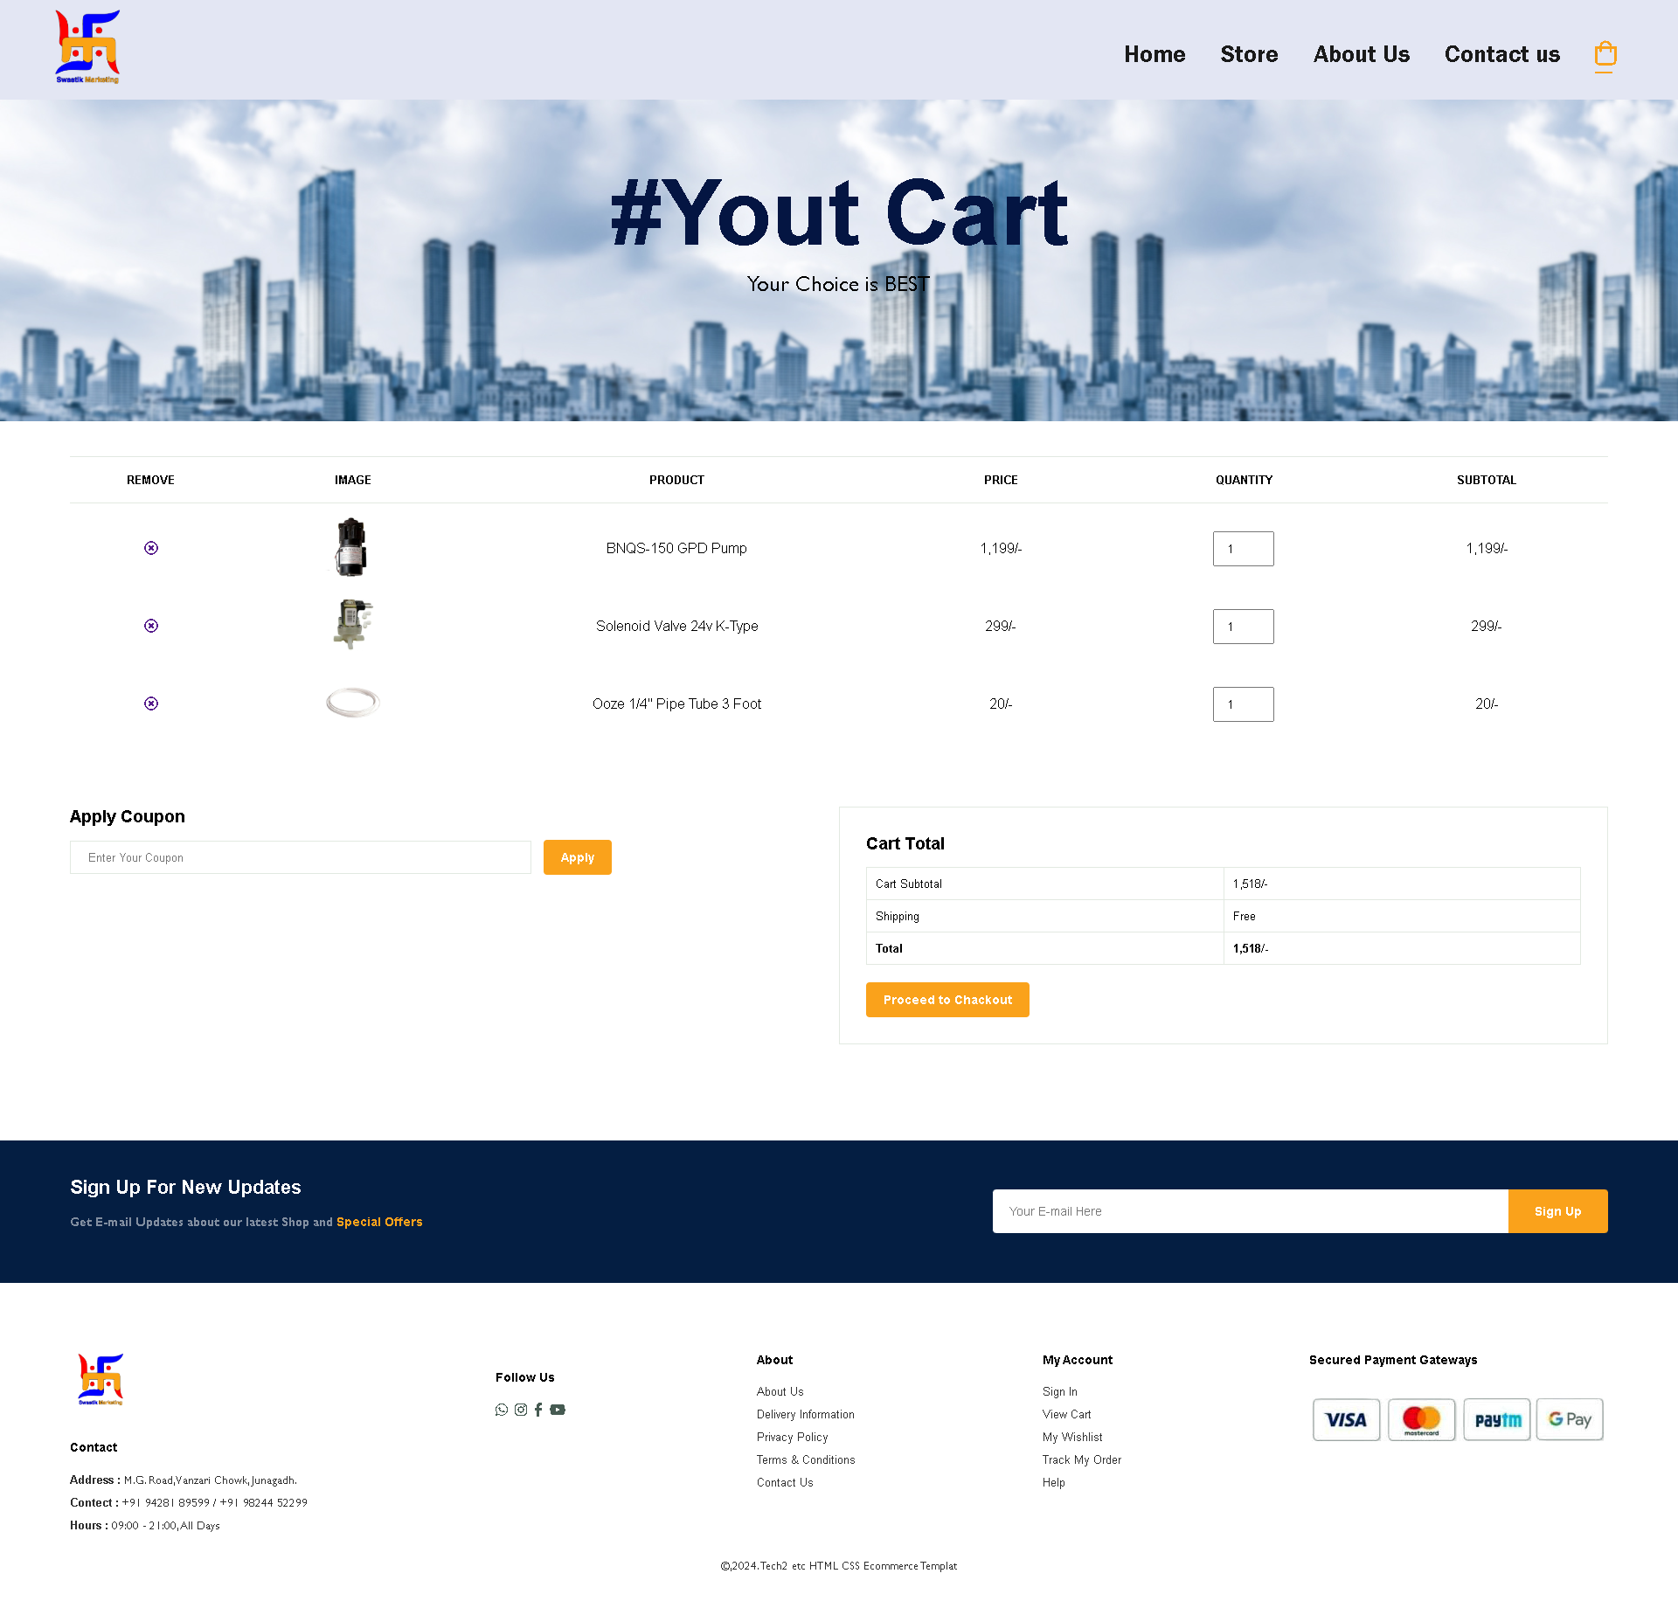

Description:

LIMITATION OF THE PROJECT

Limitation of the system

The size of the database increases day-by-day, increasing the load on the database back up and data maintenance activity.
Training for simple computer operations is necessary for the users working on the system.

FUTURE SCOPE OF THE PROJECT

Future scope of the System

This System being web-based and an undertaking of Cyber Security Division, needs to be thoroughly tested to find out any security gaps.

A console for the data center may be made available to allow the personnel to monitor on the sites which were cleared for hosting during a particular period.

Moreover, it is just a beginning; further the system may be utilized in various other types of auditing operation viz. Network auditing or similar process/workflow based applications...

- Bibliography
BIBLIOGRAPHY

BOOKS:
Herbert Schildt (2000) ‘Java Complete Reference’ Tata McGraw Hill John Zukowski (2000) ‘Mastering Java2’ BPB Publications Jamie Jaworsky ‘J2EE Bible’ Techmedia
Ian Somerville ‘Software engineering’ Rajeev mall ‘Software engineering’
Elmasri Navathe ‘Fundamentals of database systems’

ONLINE REFERENCE:
www.java.sun.com
www.w3schools.com www.wikipedia.com

